

GFD-DPP
Integration Specification
Panoramix

 |  | 

Document control
Document revision history
Version | Date | Author | Comments
0.1.0 | 19/08/2013 | Jos Van Dorpe | Initial version
0.2.0 | 20/08/2013 | Jos Van Dorpe | Version for review
0.3.0 | 21/08/2013 | Jos Van Dorpe | Added clarification on certificates and BVAC event

Approval / Signatures
Version | Date | Approved By | Signature

Table of Contents
List of Figures 3
List of Tables 4
1 Introduction 5
1.1 Objectives 5
1.2 Intended Audience 5
1.3 Scope 5
1.4 References 5
1.5 Assumptions 5
1.6 Definitions 5
2 GFD-DPP Initiative and Assuralia 6
2.1 GFD-DPP Initiative – Current scope 6
2.2 First extension - Assuralia BVAC Messages 6
3 Message Structure 8
3.1 Single Message 8
3.2 BVAC Event 9
3.2.1 Message structure of BVAC Event 10
3.2.2 Field definition 11
4 Integration 12
4.1 Authentication & encryption 12
4.1.1 Insurer SSL Certificate (for web service) 12
4.1.2 Insurer X.509 Certificate (for sftp and web service) 12
4.1.3 TIP System SSL certificate (for web service) 12
4.1.4 TIP System X.509 certificate (For web service) 13
4.2 Technical Registration 13
4.2.1 Insurer information 13
4.2.2 Delegation of retrieval of BVAC messages 13
4.2.3 An example to clarify 14
4.3 Webservice 15
4.3.1 Authentication & secure message transfer 15
4.3.2 Flow 15
4.3.3 Input & Output Message 16
4.3.4 WSDL and XSD 16
4.4 SFTP 17
4.4.1 Authentication & secure message transfer 17
4.4.2 Flow 17
4.4.3 Output File 17

List of Figures
Figure 1 - Single Message hierarchy overview 8
Figure 2 - Single Message Specification 9
Figure 3 - BVAC Event definition 10
Figure 4 - Example delegation 14
Figure 5 - Example encryption in context of delegation 15
Figure 6 - Get BVAC messages 16
Figure 7 - Error response structure 16

List of Tables
Table 1 - References 5
Table 2 - Example technical registration parameters 14

Introduction

Objectives
This document establishes a set of requirements and constraints for the interface between insurers and the TIP system for retrieval of BVAC messages.

Intended Audience
This document is intended for use by architects, developers and testers of the applications identified.

Scope
This document outlines the interface requirements to support the Assuralia business events in the TIP system solution. It details the integration procedure expected to be implemented by the insurers be able to use the services offered by the TIP System for retrieval of BVAC messages.

References
Ref | Name | Version | Location
1 | GFD-DPP_Glossary | 0.0.2 | ACN Sharepoint:
2 | GFD-DPP_Application_Design_Assuralia | 1.2.0 | ACN Sharepoint
3 | Single message format | 1.1.0 | GFD-DPP SVN
Table 1 - References

Assumptions
No assumptions currently defined.

Definitions
For definitions used in this document, please refer to glossary (see [Ref 1]).

GFD-DPP Initiative and Assuralia

GFD-DPP Initiative – Current scope
The main high level business process supported by the GFD-DPP initiative is a Sales event, typically encased by the Provision of Pharmaceutical Care. This is initiated by a customer request, and terminated by the sales closure and possibly leads to a follow up.
The GFD-DPP solution not only enables the safe storage and retrieval of the medication delivery information in the sales event, but also foresees other services offered in the future by the professional associations of pharmacies. This new system connects different healthcare providers with each other and as a result creates added value across the board:
- A national authentic source of detailed high quality dispensation data;
- Support for the exchange of records in perspective of pharmaceutical care;
- A clear and defined view on roles and responsibilities;
- An integrated patient centric loop of pharmaceutical care;
- A unique identifier for every drug dispensation, across the entire chain, providing traceability.
- A secured exchange of pharmaceutical care data
- The introduction of a Trusted Intermediate for Pharmacies
- A system that facilitates dispatching and coherence amongst the exchanged information
- A referral register referencing the available patient data
- …
The idea is that each pharmacy will have an agreement with one or more intermediaries to handle his/her data resulting from medication deliveries; intermediaries are recognized professional pharmaceutical associations. The agreement determines which pharmaceutical care services the intermediary will provide for that pharmacy.
- The GFD-DPP introduced the Pharmaceutical Care Data Hub as the first service.
The pharmacy sends data, in a single message format, as the source of information for all agreed care services instead of separate messages per service. The pharmacy sends the message to the intermediary (TIP) of his choice, as configured locally in his software.
The systems involved, are connected by secure Internet-based communication lines through the eHealth service bus:
- The Connector Module at the pharmacy software and thus used by the pharmacist involved in the registration and consultation of dispensations.
- The TIP system performs quality control and filters data sent to the Pharmaceutical Care Data Hub (initially).
- The Pharmaceutical Care Data Hub is the authentic source of dispensation data offering services to store and access the data.
This is a segregated command and request approach. In practice this means the TIP system is contacted for management (create update delete) of data, while the PCDH is contacted for consulting (read) of data.
The connector module is one of the components in the end-to-end solution of the GFD DPP project. The connector module provides an open source reference implementation of a full client able to achieve the different functionalities in scope of the GFD DPP project (including authentication and encryption). The connector module is delivered as JAR and DLL libraries to the pharmacy software vendors.

First extension - Assuralia BVAC Messages
Next to the national compulsory health insurance (RIZIV-INAMI), a citizen has the possibility to contract complementary coverage for health related out-of-pocket costs with the insurer(s) of his choice.
Contrary to interventions by RIZIV for pharmaceutical products using a third party settlement process, the patient still has to advance the amount and claim reimbursement from his in case of complementary insurance. To this means the pharmacist can issue a BVAC attestation clearly identifying the patient, the product(s) and the price among other things. The patient/insured person submits the BVAC to his insurer by post, handover or other permitted channels to obtain a (partial) reimbursement depending on the specifics of his contract.

As the personal share of medical expenses (portion of the cost not covered by INAMI) is increasing, patients are increasing their complementary coverage. At present an estimated 3 million BVAC attestations are issued yearly.
In the context of the Panoramix project, we will implement an Assuralia flow in the TIP that will automate the transfer of the information contained within the BVAC attestation from pharmacist to insurer enabling reimbursement to the patient/insured person. This will reduce the administrative load for
- the patient: no more manual intervention to claim reimbursement
- the insurer: reduced handling and recoding as structured information is transferred electronically.
This flow can be called by pharmacy software through connector module.
Remark that some use AssurCard as an aggregator to interact with care providers, the TIP will thus transfer the BVAC attestations to AssurCard instead of directly to these respective.
At present only the electronic transfer of the BVAC data from pharmacist to insurer is in scope.

Message Structure

Single Message
The single message format is an XML specification used to communicate pharmaceutical information. The message structure contains a hierarchy of events and entities in its body.
- Events correspond to pharmaceutical care actions performed by the pharmacist.
- Entities are the data objects manipulated by or associated with events.
  - These are either part of, or referenced by, events. The latter is preferred if multiple events reference the same entity.
The following simplified diagram contains fictional elements to illustrate the difference between events and entities. In this case, a revocation is an event that references a dispensation delivery.
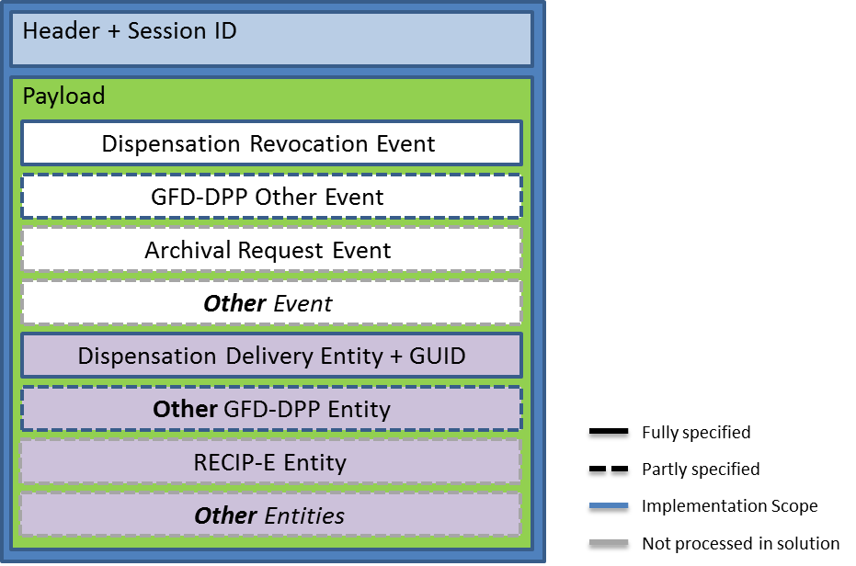
Figure 1 - Single Message hierarchy overview
More specifically, the diagram below shows the structure as it exists within the actual schema.
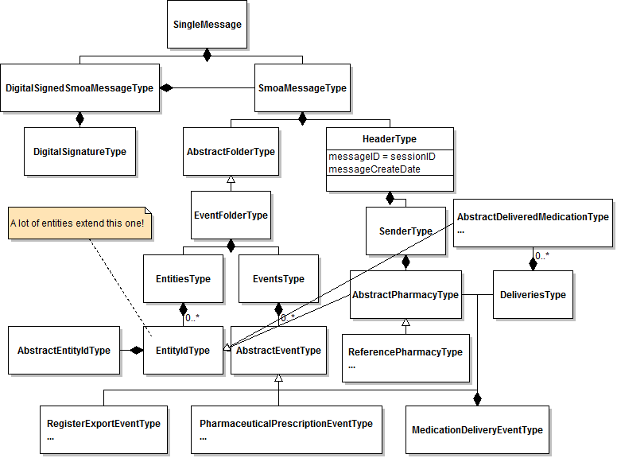
Figure 2 - Single Message Specification
- Black diamond mean “is composed of” (contains)
- White arrow means “extends”
- If no cardinality is written, it means 0..1
- Ellipses (…) in an entity mean the entity has more attributes or extensions not shown in the diagram.

This single message concept will be extended with a new type of event, the “BVAC Event”. The details of the single message can be found in [Ref 3] or can also be provided on request.

BVAC Event
The vehicle for sending Assuralia data is the BVAC document. The BVAC document will be part of the Single Message and will be contained in a new event type “BVAC Event”.
In the diagrams below, the graphical conventions are:
- yellow for a data field;
- white blocks indicate composite elements;
- striped blocks are optional fields not filled in the shown exchanged message.

Message structure of BVAC Event
Figure 3 - BVAC Event definition

2 fields of note are the S-GUID and the BVAC Document Id. Both are auto-generated and unique id’s across the pharmacies, TIP System and insurer. The S-GUID is used for end-to-end traceability across any type of message passing the TIP system, where the BVAC document Id is particular to the BVAC message flow. One S-GUID exists per single message and one BVAC document id exists per BVAC message. Since a single message only contains one BVAC document id, there is also a 1 to 1 mapping between both ids, but this cannot be taken as a fixed assumption, since in the future a different setup with more than 1 BVAC message per Single Message could be envisioned.
The insurer is requested to also keep both the S-GUID and BVAC Document ID when treating and archiving the BVAC messages.
Other fields are further defined in section 3.2.2 Field definition

Field definition
Referenced document for more details:

Integration
The “Get BVAC DATA” service will allow to retrieve BVAC messages sent by pharmacies from the TIP system.
The TIP System allows 2 mechanisms:
- SFTP: The TIP Sytem provides file access to the BVAC messages by means of SFTP over SSH.
- Webservice: The TIP System exposes a standard web service that allows access of the BVAC messages for a particulare Assuralia member.
Both options imply that some technical processing must be performed on client side (such as encryption/decryption, setting up a SSH connection for SFTP, …). This technical processing must be implemented by the insurers..

Authentication & encryption

Insurer SSL Certificate (for web service)
The insurer willing to use the webservice, is required to request an SLL certificate from a valid certificate authority with a linked public /private key pair (2048 bits) and needs to provide the public part to the TIP System at configuration. The certificate + public/private key pair is expected to be renewed every year between TIP and Insurer through manual agreement between APB (Farmaflux) and Insurer (or AssurCard).
This SSL certificate is used to setup the HTTPS session when using the webservice approach.

Insurer X.509 Certificate (for sftp and web service)
The insurer willing to use the web service or SFTP is required to request an X.509 certificate from a valid certificate authority with a linked public /private key pair (2048 bits) and needs to provide the public part to the TIP System at configuration. The certificate + public/private key pair is expected to be renewed every 3 years between TIP and Insurer through manual agreement between APB (Farmaflux) and Insurer (or AssurCard).

This X.509 certificate is used
- SFTP
  - Setting up the SSH session with the file server uses the X.509 certificate (so not username/password)
  - The content of the file found, is encrypted with the public key of the end-insurer and needs to be decrypted by its private key
- Web service
  - The get BVAC data request message is signed with the X.509 certificate of the requestor, which is checked by the TIP System
  - The web service return messages are encrypted with the public key of the end-insurer and need to be decrypted by its private key.

TIP System SSL certificate (for web service)
The insurer willing to use the web service, should have the TIP System SSL certificate installed on its server. This is provided at time of configuration and is valid for a period of 1 year. Between a period of 3 to 1 month before the end of the year, the insurer will be provided with a new public key.
This SSL certificate is used to setup the HTTPS session when using the webservice approach.

TIP System X.509 certificate (For web service)
The insurer willing to use the web service, should have the TIP System public key on its server. This is provided at time of configuration and is valid for a period of 3 years. 3 months before the end of the 3 year period, the insurer will be provided with a new public key.

It is used for the get bvac data web service request message which needs to be encrypted with the public key of the TIP System

Technical Registration

Insurer information
In order to allow access to the TIP system to retrieve BVAC messages, the insurer needs to provide a number of technical configuration parameters:
- Name
- CBFA number
- End-point-type: SFTP or HTTPS (web service)
- SSL Certificate (public) – when using webservice
- X.509 Certificate (public)
- A delegation list of parties (indicated by CBFA numbers) that may retrieve BVAC messages for this insurer

Note on switching from SFTP to web service
An insurer is expected to choose or SFTP or Web service. In the case where an insurer wishes to switch from SFTP to Web service, please mind that
- An insurer can only start calling the Get BVAC web service when the insurer configuration is adapted in the TIP System by APB. As long as APB does not confirm the configuration change, the insurer will need to keep doing SFTP.
- Once a file has been created for SFTP, it is no longer possible to retrieve the contained BVAC records by web service so when an insurer switches from SFTP to Web Service, it can occur that there are still files present in the SFTP directory of the insurer. In this case it’s up to the insurer to retrieve these files before they are deleted by the nightly deletion batch

Delegation of retrieval of BVAC messages
An insurer can delegate the retrieval of its BVAC messages to one or more insurers, or in general other parties having a CBFA number. E.g. Assurcard has a number of Insurers for which it can retrieve BVAC messages.
- Both parties (delegator and delegate) need to have passed the technical registration, and for both parties the public keys need to be known . This list of parties to which it delegates, is communicated by the delegator (not delegate) also at the time of technical registration.
- Retrieval of the BVAC messages is transparent for a non-delegated party as for a delegated party:
  - Authentication and authorization of the requestor is done on the basis of the public/private key-pair of the requestor
  - In the request it is specified for which end-insurer the BVAC messages are meant
  - The distinct BVAC messages are encrypted (message by message) for the end-insurer
- Important for this setup is also that it is possible that multiple parties are allowed to retrieve BVAC messages for one end-insurer. This retrieval happens on a first-come-first-served basis. If one party with access to the messages has retrieved them, then a second party which also has access to these messages will no longer find them on the TIP System.

An example to clarify
Assume we have a party A which retrieves BVAC messages for parties x and y. Assume we have a second party B which can also retrieve messages for party x.

Figure 4 - Example delegation

During the technical setup, we will have following information
Name | CBFA | End-point-type | SSL Certificate | X.509 Public Key | Accessible by (CBFA)
A | 1111 | HTTPS | @SSL Cert party A@ | @Public key party A@ | 1111
B | 2222 | SFTP | - | @Public key party B@ | 2222
x | 3333 | SFTP | - | @Public key party x@ | 3333, 1111, 2222
y | 4444 | SFTP | - | @Public key party y@ | 4444, 1111
Table 2 - Example technical registration parameters

When party A wants to retrieve the BVAC messages for both x and y, he
- Sets up a HTTPS session using its SSL certificate (@SSL Cert party A@)
- Sends two requests (i.e. 2 webservice calls), one for CBFA 3333 and one for CBFA 4444. Each request is signed with its private key (@Private key party A@)
- Two return messages are returned, each containing a number of BVAC messages, with each BVAC message encrypted with the public keys of the end-insurers (@Public key party x@ & @Public key party y@)

Figure 5 - Example encryption in context of delegation

Webservice

Authentication & secure message transfer
A HTTPS session is setup by the insurer using its SSL certificate.
Further authentication is done by signing of request messages with the own private key to allow the TIP System to validate the originator of the message. See section below for further explication where signing is done.

Flow
The BVAC messages are reachable through HTTPS for all authenticated insurers.

- Calling party sets up a HTTPS connection to the TIP System using its SSL certificate
- Calling party creates and sends a request message
  - Containing amongst other the CBFA number for which the BVAC messages need to be retrieved
  - Signed with the private key of the calling party
  - Encrypted with the public key of the TIP system
- TIP System checks the request message
  - Decrypts with the private key of the TIP system
  - Checks the signature against the public key of the calling party
  - Checks if the calling party has access to the BVAC messages of the CBFA indicated in the request message (using the parameters provided during technical registration)
- TIP System creates a return message
  - Retrieves the BVAC messages for the CBFA indicated. These are each in its turn already encrypted with the public key of the insurer to which the CBFA number belongs
  - Puts these BVAC messages together in an aggregated message
  - Encrypts with the public key of the calling party
- Calling party treats the return message
  - Depending on the setup
    - Decrypts the individual BVAC messages with the private key linked to the insurer for which the messages where requested
    - Or potentially in the case of a delegation where the private key of the delegator is not kept at the delegate: Passes along the BVAC messages to the delegator for which it retrieved the message. This delegator party is then responsible for decrypting the individual BVAC messages with its private key.

Input & Output Message
Figure 6 - Get BVAC messages

Figure 7 - Error response structure
If any synchronous exchange results in a functional error, the error message depicted in Figure 7 is returned. This includes an error code and a message in three different languages (nl, fr, en).
Please mind that the web service will return multiple ‘Single Messages’, namely one per BVAC message.

WSDL and XSD
Below the current format of WSDL and corresponding XSD for the get bvac data web service.

SFTP

Authentication & secure message transfer
The access to the SFTP directories are configured on infrastructure to be only accessible by the authenticated insurer by verifying their public key. The TIP SFTP setup will associate the user name of the insurer with the public SSH Key, so there is no need to each time enter a password. The data is transferred from TIP to Insurer through a secure channel (SSH-2) with data encryption based on a temporary agreed symmetric session key based on AES-192 algorithm.

Flow
- The TIP system will have a nightly “BVAC extract” batch that will extract all BVAC messages for every insurer that is configured with end-point-type = SFTP. The distinct BVAC messages are encrypted with the public key of the target insurer and grouped into an aggregate file per CBFA
- The calling party sets up an SFTP connection to the TIP System file server using its X.509 certificate
- The TIP System file server only allows access to the directories belonging to the insurers for which the accessing party has access (using the parameters provided during technical registration)
- The file can then be picked up by an insurer through SFTP connection
- After successful retrieval of the file, the insurer is expected to delete the file. This indicates to the TIP System that the retrieval was a success.
- Depending on the setup, the calling party
  - Decrypts the individual BVAC messages with the private key linked to the insurer for which the messages where requested
  - Or potentially in the case of a delegation where the private key of the delegator is not kept at the delegate: Passes along the BVAC messages to the delegator for which it retrieved the message. This delegator party is then responsible for decrypting the individual BVAC messages with its private key.
Please mind that since we do not know which party will be retrieving the file, we cannot encrypt the aggregate message. Only the individual messages out of which the aggregate message is made up, is encrypted.

Output File
There is one output directory for each CBFA indicated by its CBFA number /<CBFA>/
The file name of the nightly extracts, is BVAC-<CBFA>-<datetime>.xml where <CBFA> is the CBFA number of the insurer and <date> is the datetime of the extract.
E.g. for the party x as in our previous example, you could have following files (assuming the files where not retrieved in the past 2 days).
/3333/BVAC-3333-2013-08-19T23:32:52.xml
/3333/BVAC-3333-2013-08-20T23:30:12.xml
The file format is XML and looks like:
<bvac-list>
<CBFA>0196</CBFA>
<bvac>
<bvac-document-id>12345687987654321</bvac-document-id>
<bvac-document>
<!—ENCRYPTED (for Insurer corresponding with CBFA) message structure as defined in chapter 3
-->
</bvac-document>
</bvac >
<bvac >
<bvac-document-id>12345687987654322</bvac-document-id>
<bvac-document>
<!-- ENCRYPTED (for Insurer corresponding with CBFA) message structure as defined in chapter 3
-->
</bvac-document>
</bvac >
…
</bvac-list>

Please mind that this file contains multiple ‘Single Messages’, namely one per BVAC message.

– End of document –

